Andy Individual Report

**EX 1 : first.s**

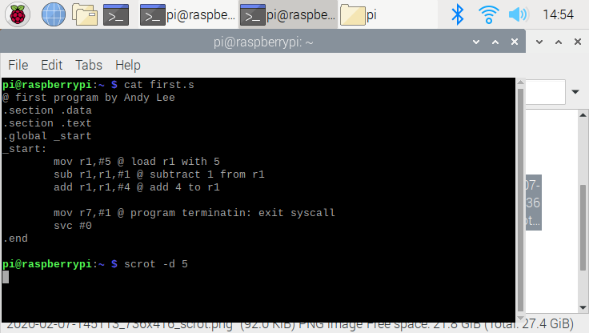

**Result**

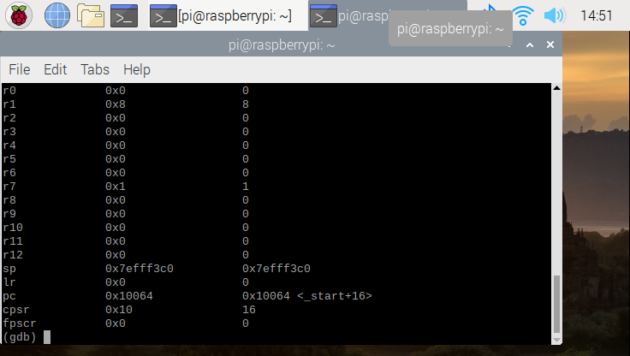

**Summary**

The assign task for first.s was to copy the code that instruction provide, and explain why result come out like the second photo.

To start with, we have loaded the register 1 and assigned the numerical number of 5. By loading the register, now computer have assigned the address of r1, which we could do a arithmetic operation using this path. On second line, as u could see from the top photo, I declared the subtraction function that subtract “1” from r1. Therefore, the value for r1 is now become 4. Follow by second, on third line, I have declared another functions “addition” with 4. This will add the numerical value of 4 in to r1. Since r1 is 4 before adding, the result of overall program will be 8.

Now going to the debugger, we could see the r1 have decimal value of 8, thus the program work perfectly.

**EX 2 arithmatrics1.s**

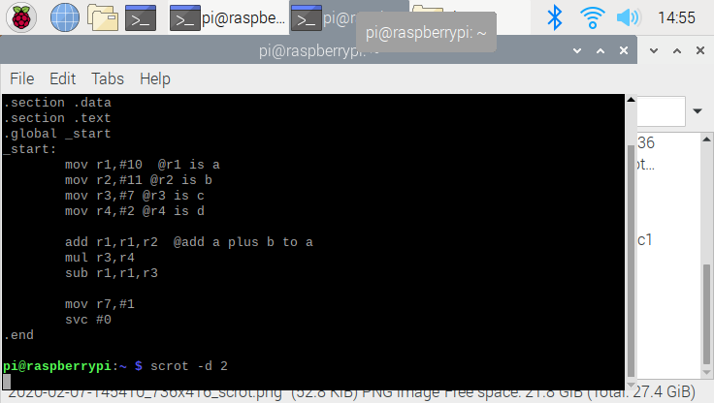

Result

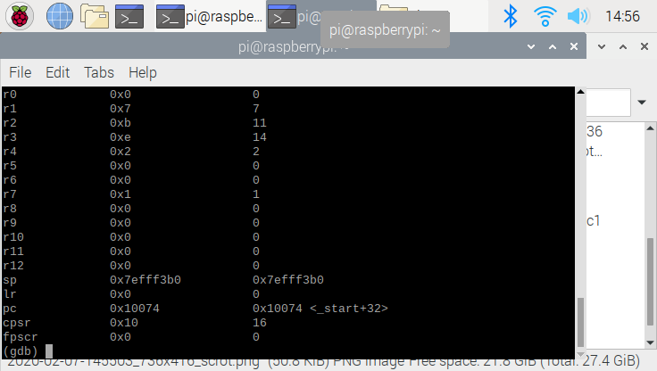

**Summary**

The task for arithmatrics1.s is to find equation of “A = (A+B) – (C* D) using ARM assembly.

The first this I do was load 4 registers, since we need 4 variable. I have used the comment to indicates which register represents which variable. (i.e A represent r1). After the loading, I have started with function “add” that add r1 and r2. This addition will be stored in r1. In another word, the added value of two number will be store in to “A”. On second operation “mul”, I have multiplied r3 and r4, then store the operated value to the r3. In another word, the “C” will not have “14”.

So far the values for A is 21 , C is 14. Now we only have one other operation, which is subtraction. We simply said subtract A -C and store it to A. Overall the final answer of A is now 7

After coding, I have go to the debugger mode, and the answer we got is correct thus the program accomplished the achievement. s